Drools Guvnor Functional Document

Prepared by/Modified by |  | Role |  | Date of preparation/ Modification
Pinky/Honey |  |  |  | Dec 10 2012
Reviewed by |  | Role |  | Date of Review
Approved by |  | Role |  | Date of Approval
Circulation List |  |  | Version Number of the Template | 1.0
VERSION NUMBER of the work product | V1.0

Table of Contents

1 Overview: 3
2 INTRODUCTION: 4
3 api’s rEQUIRED: 5
4 PURPOSE AND USE OF aPI’S REQUIRED: 9
5 ECLIPSE GUVNOR INTEGRATION : 9

Overview:
This document will provide the functional and technical details of the Drools Guvnor.

Introduction
A business rules manager allows people to manage rules in a multi user environment; it is a single point of truth for your business rules, allowing change in a controlled fashion, with user friendly interfaces.
Guvnor is the name of the web and network related components for managing rules with drools. This combined with the core drools engine and other tools form the business rules manager.
The main roles of people who would use Guvnor are: Business Analyst, Rule expert, Developer, Administrators (rule administrators etc.).
DROOLS GUVNOR
Drools Guvnor is a centralized repository for Drools Knowledge Bases, with rich web based GUIs, editors, and tools to aid in the management of large numbers of rules. Drools allow you to create executable knowledge bases. The repository component is where you can store versions of rules, models, functions, processes etc. that all relate to these knowledge bases. Access is controlled, and it is possible to lock down access and restrict features so domain experts (non-programmers) can view and edit rules without being exposed to all the features at once.

API’s Required
The following is a description of the important libraries that make up JBoss Drools.
- 1.knowledge-api.jar
- 2.knowledge-internal-api.jar
- 3.drools-core.jar
- 4.drools-compiler.jar
- 5.drools-jsr94.jar
- 6.drools-decisiontables.jar

Purpose and use of API’s Required.
- 4.1 knowledge-api.jar
- This provides the interfaces and factories. It also helps clearly show what is intended as a user API and what just an engine API is.

- 4.2 knowledge-internal-api.jar
- This provides internal interfaces and factories.

- 4.3 drools-core.jar
This is the core engine, runtime component. Contains both the RETE engine and the LEAPS engine. This is the only runtime dependency if you are pre-compiling rules (and deploying via Package or Rule Base objects).
- 4.4 drools-compiler.jar
- This contains the compiler/builder components to take rule source, and build executable rule bases. This is often a runtime dependency of your application, but it need not be if you are pre-compiling your rules. This depends on drools-core.

- 4.5 drools-jsr94.jar
- This is the JSR-94 compliant implementation, this is essentially a layer over the drools-compiler component. Due to the nature of the JSR-94 specification, not all features are easily exposed via this interface. In some cases, it will be easier to go direct to the Drools API, but in some environments the JSR-94 is mandated.
4.6 drools-decisiontables.jar
This is the decision tables 'compiler' component, which uses the drools- compiler component. This supports both excel and CSV input formats.

Eclipse Guvnor Integration

In the Eclipse workbench menu, choose Window, Open Perspective, Other to get the perspective list and then choose "Guvnor Repository Exploring." After opening the Guvnor perspective, the first task is to make a connection to a Guvnor repository. This is handled by the Guvnor Connection wizard. The basic configuration requires authentication, but user and password can be anything. Once the Guvnor connection wizard is complete, the new Guvnor repository connection will appear in the Guvnor Repository Explorer.
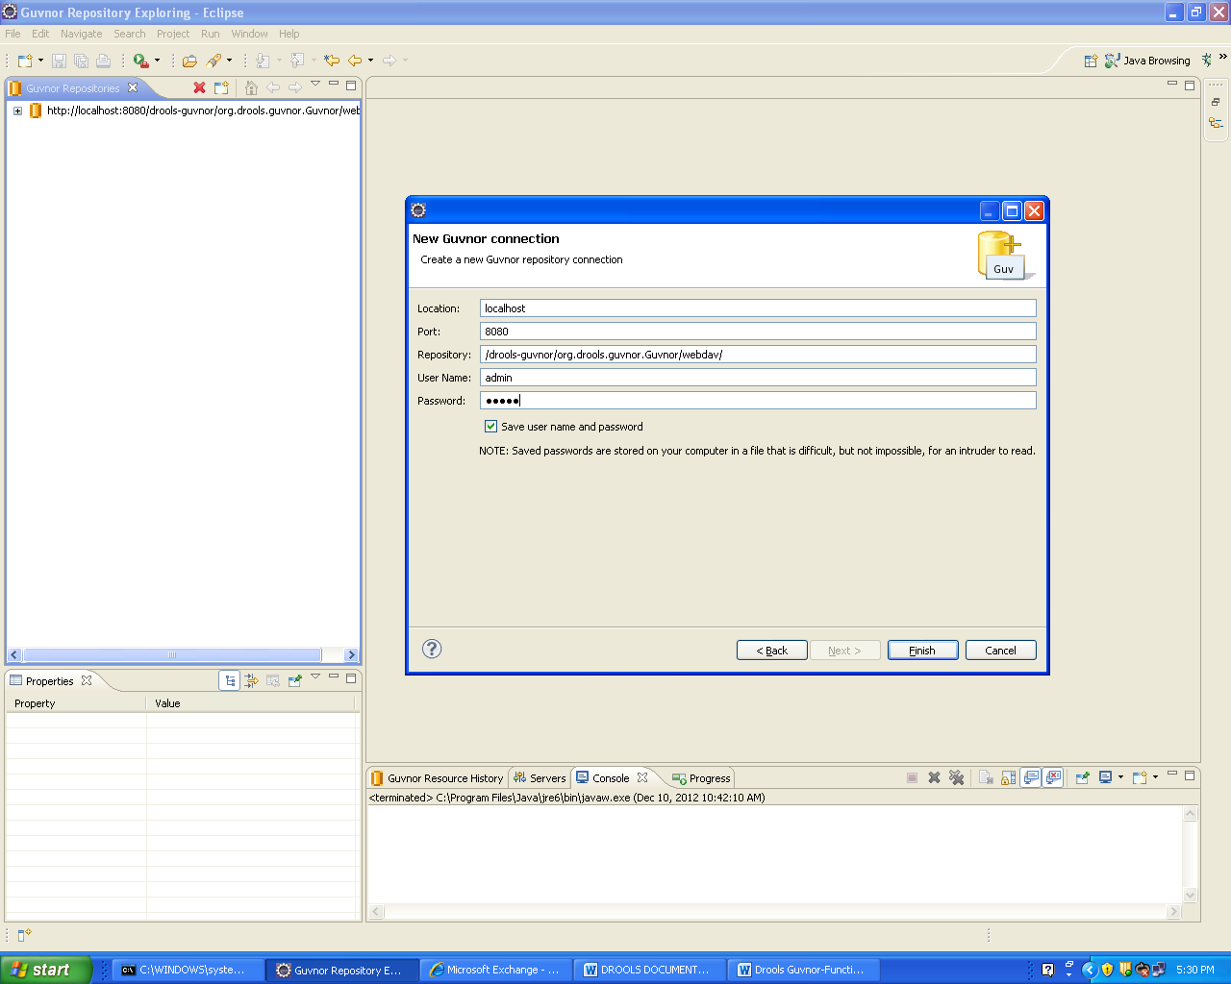

Right click on Guvnor Repository select “Open Guvnor Console” which will show a window as shown below.

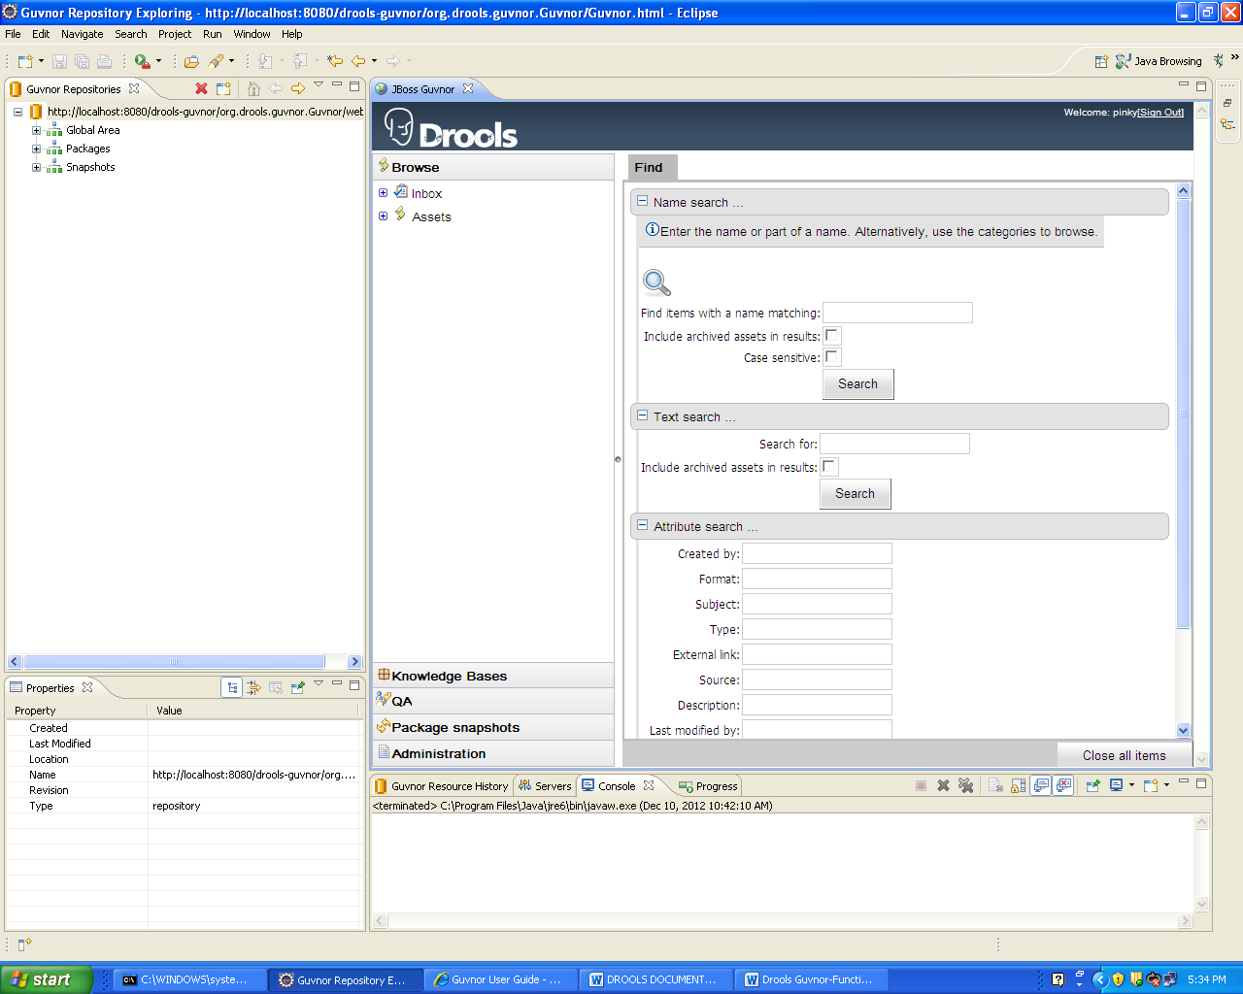
5.1 Category
Categories allow rules (assets) to be labeled (or tagged) with any number of categories that you define. Rules can belong to any number of categories. You can also remove/add new categories - you can only remove them if they are not currently in use.

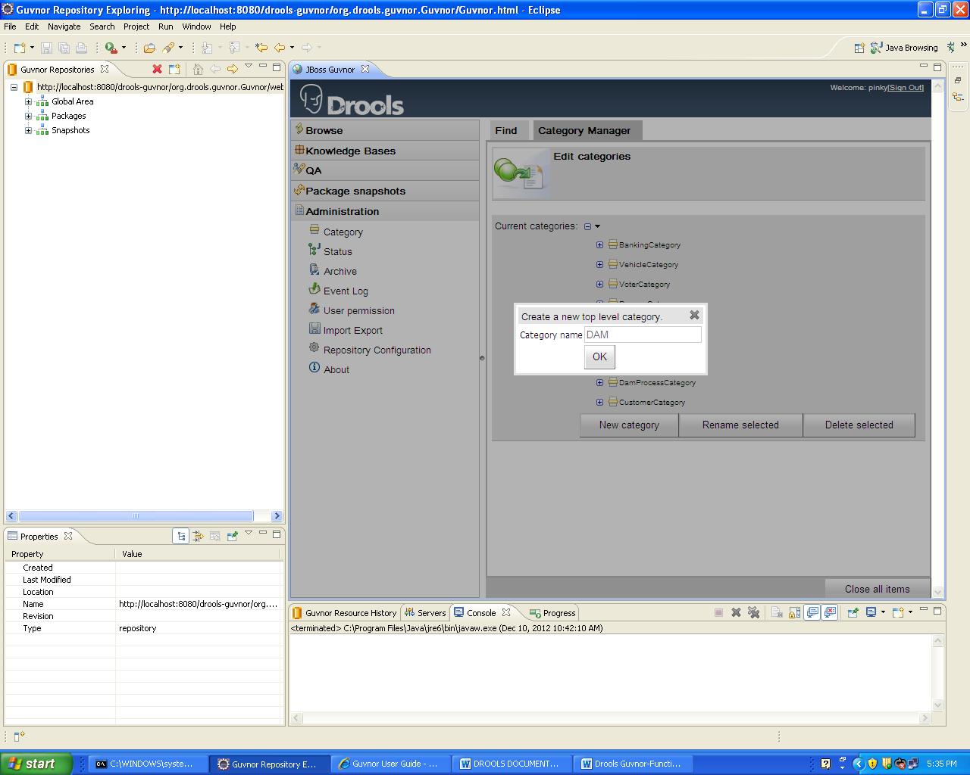
5.2 Package
Rules and other assets belong to a Package, a container for related artifacts.
  - Select the "Knowledge Bases" section of the menu-bar on the left-hand side of the Guvnor main window.
  - Click on "Create New" to show the types of asset that can be created and select "New Package". Click on "Create new package" and enter a suitable name.
  - Click "Create package".
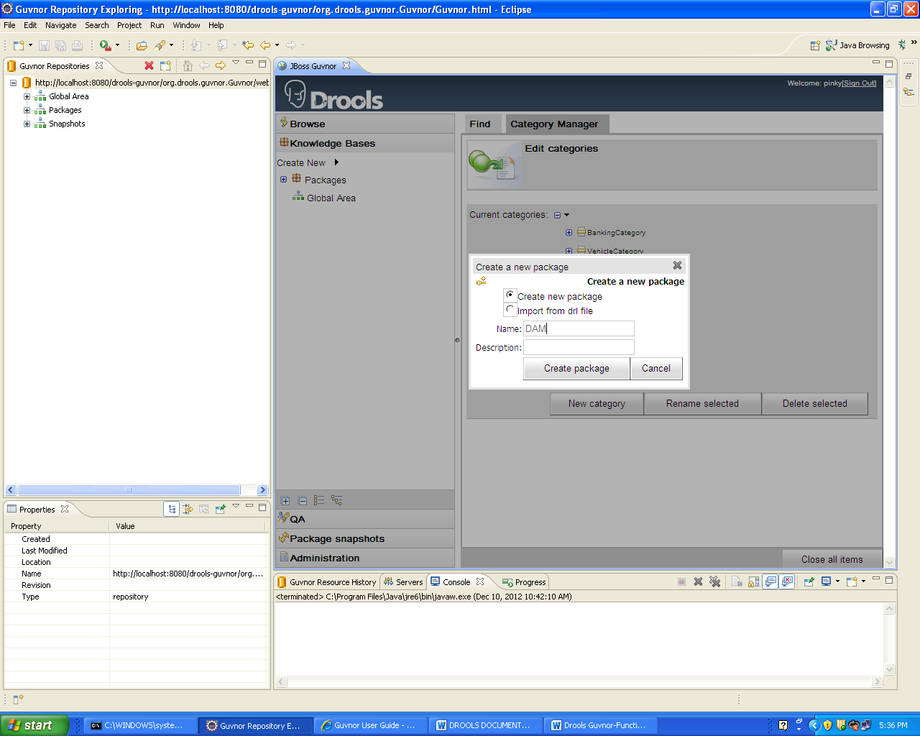

Rules
Rules need a fact model (object model) to work. The model defines your domain artifacts representing the knowledge you wish to manage.
  - Select the "Knowledge Bases" section of the menu-bar on the left-hand side of the Guvnor main window.
  - Click on "Create New" and select "Upload POJO model JAR" (if you have a JAR containing your Java model).
  - Enter a suitable name and ensure the package you defined above is selected in the "Create in package" dropdown.
  - Click OK
  - The POJO Upload screen is displayed.
  - Click on "Browse" and select your JAR file.
  - Click on "Upload".
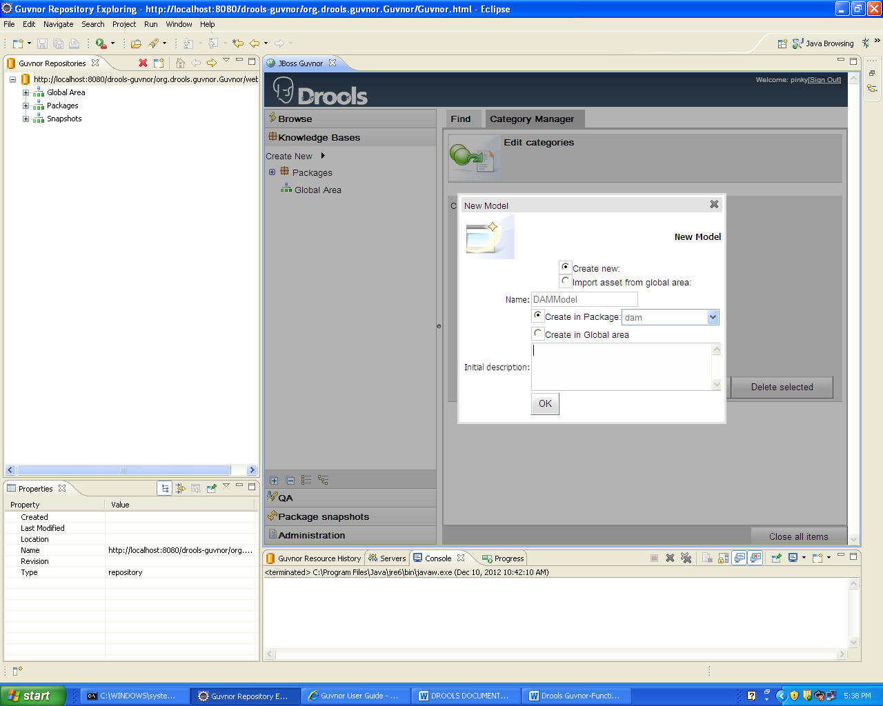
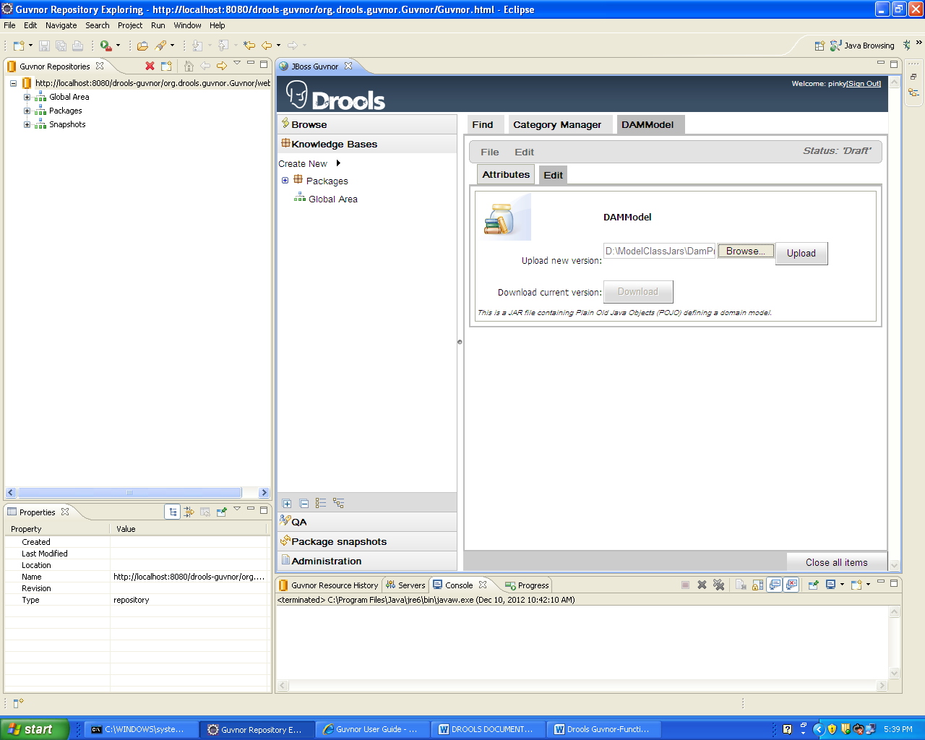

Writing Rules
- Select the "Knowledge Bases" section of the menu-bar on the left-hand side of the Guvnor main window.
- Click on "Create New" and select the type of rule you want to create.
- Chose "New Rule".

  - Enter a suitable name and ensure the package you defined above is selected in the "Create in package" dropdown.
  - Select "Business Rule (guided editor)" in the "Type (format) or rule" dropdown.
  - Click "OK".
The Guided Rule Editor will open. It represents a single DRL rule. You can add and edit Conditions and Actions using the model, or models, which are available in the package. When you are done with rule editing, you can check in the changes (save), or you can validate or "view source" (for the effective source).
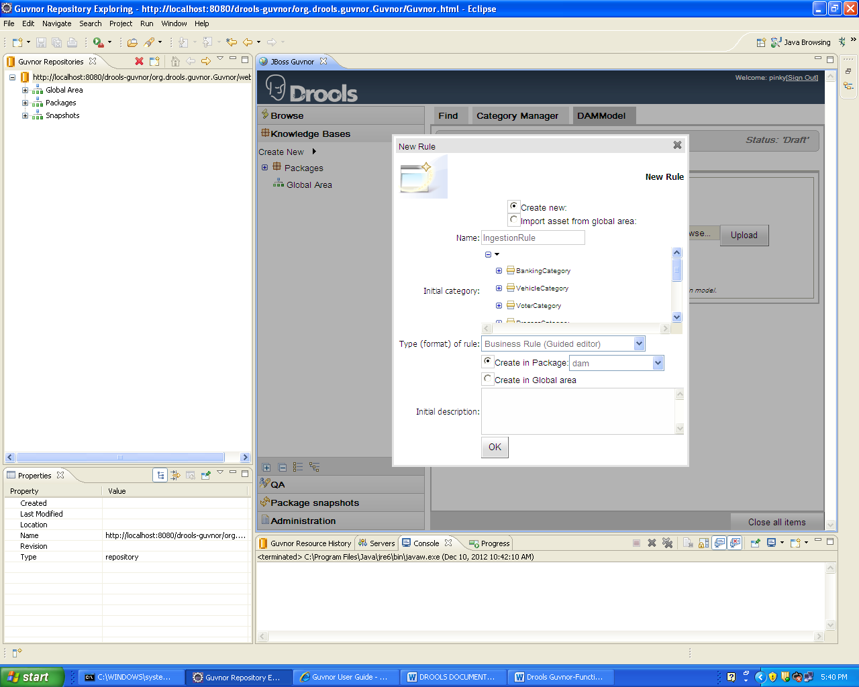

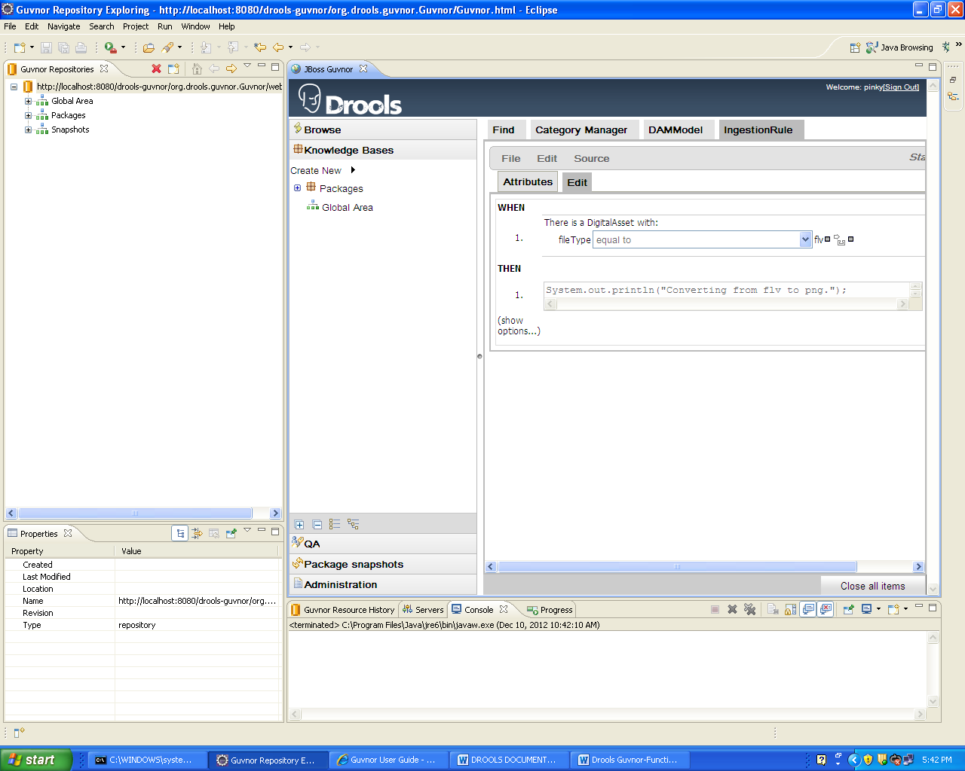

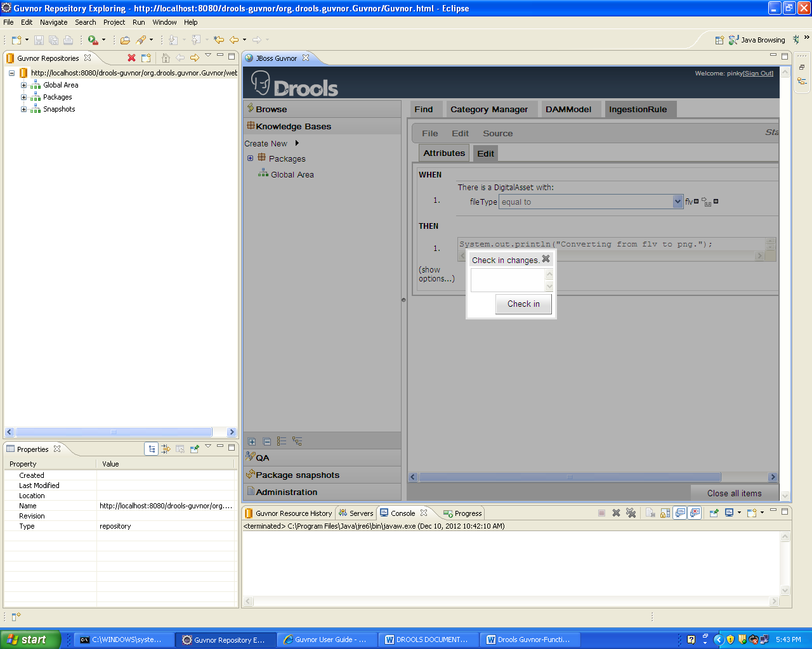

Deployment
After you have edited some rules in a package, you can click on the package feature, open the package that you wish, and build the whole package. If that succeeds, then you will be able to download a binary package file which can be deployed into a runtime system.
You can also take a "snapshot" of a package for deployment. This freezes the package at that point in time, so any concurrent changes do not affect the package. It also makes the package available on a URL of the form:
"http://<yourserver>/guvnor-webapp/org.drools.guvnor.Guvnor/packages/<packageName>/<snapshotName>"
After building the package we will get a set of URLs which include:
URL for package documentation
URL for package source
URL for package binary
URL for running tests
Change Set
POJO Model
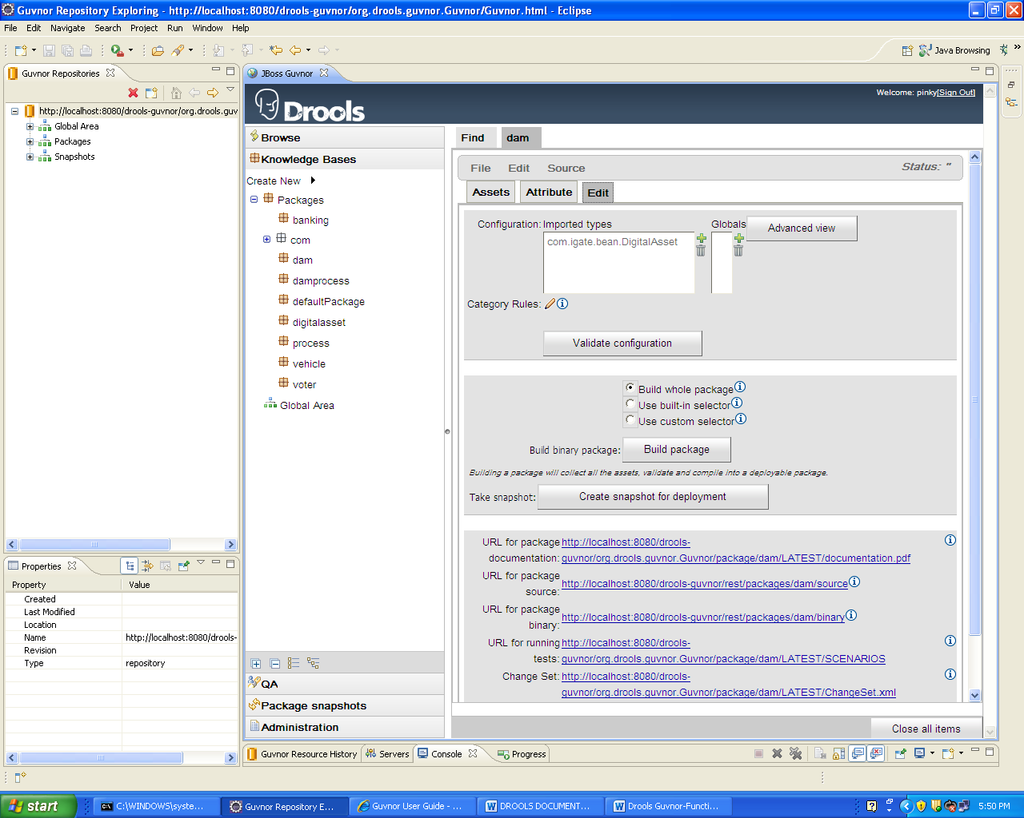
Copy the content of the Change Set URL and put that in changeset.xml placed in classpath. We can access the rules defined in the package using the URL.
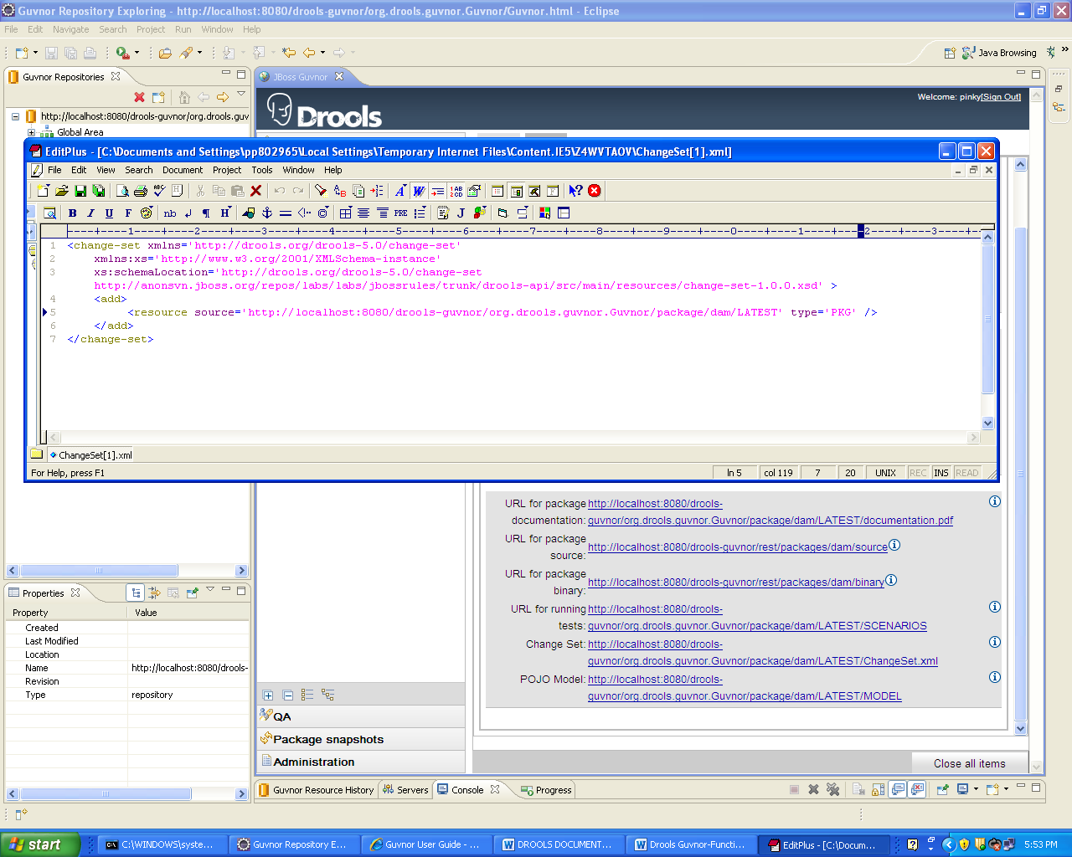

Guvnor Rule package from an external application
The knowledge agent is a component which is embedded in knowledge-api. To use this, you don't need any extra components. In fact, if you are using Guvnor, your application should only need to include the knowledge-api and drools-core dependencies in its classpath (drools and mvel JARs only), and no other rules specific dependencies.
Once you have "built" your rules in a package in Guvnor you are ready to use the Knowledge agent in your target application. The agent that will build a new Knowledge Base from the files specified in the path String. It will poll those files every 60 seconds, which is the default, to see if they are updated. If new files are found it will construct a new Knowledge Base. If the change set specifies a resource that is a directory its contents will be scanned for changes too.

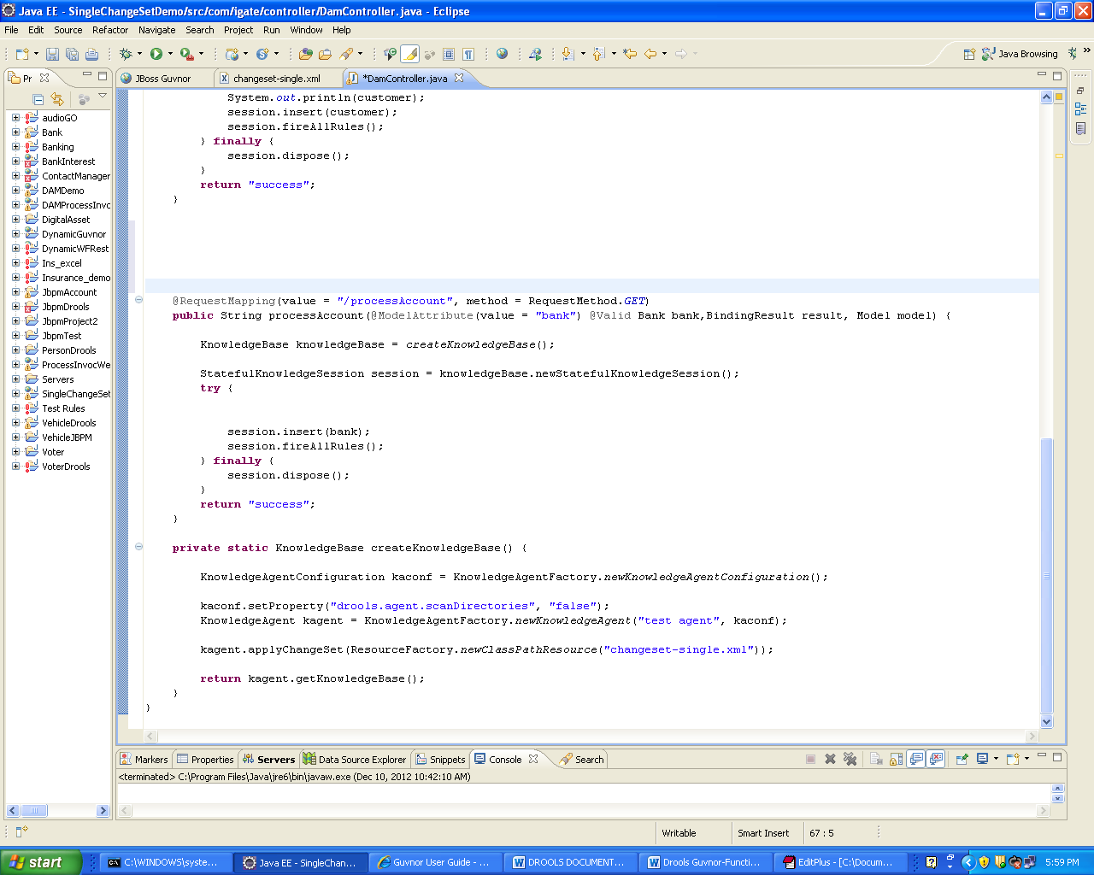
Basic Guvnor usage includes creating a category and package, uploading a model, define some rules on the model and package the package, so it can be called by an external application using Drools.

